Predicting Academic Performance from Screen Time and Lifestyle Factors Using Machine Learning :

Challa Noé
Abstract

This study shows the relationship between screen time, lifestyle factors, and academic performance among university students using machine learning techniques. Previous research showed that excessive screen time negatively affect academic performance. However, many studies only focused on total screen time using simple linear regression models. The goal of this research is to improve previous methodologies by applying multiple linear regression and including additional lifestyle variables.
The study uses the Student Screen Time vs. CGPA Analysis – 2026 dataset from Kaggle, which contains information from more than 550 undergraduate students. And many variables including daily screen time, class attendance, sleep duration, gaming activity, social media usage, online study hours, and previous semester CGPA. The target variable is the students’ current CGPA.
Before the analysis, data cleaning procedures were performed. Missing and inconsistent values were removed, categorical variables were encoded, and numerical features were normalized. Exploratory Data Analysis (EDA) helped us to identify patterns and correlations between variables.
Unlike previous studies focusing only on screen time, this research evaluates the combined variables of lifestyle factors on academic performance. Multiple linear regression is used to determine the independent influence of each variable and to improve prediction accuracy. The findings will help to understand better how digital habits and lifestyle behaviors influence student academic success.

I Introduction :

Background
These days the rapid growth of digital technology has significantly increased daily screen exposure among university students but also Kids and adults. Smartphones, laptops, social media platforms, streaming services, and online learning tools became an important part of students’ academic and personal lives. While digital devices provide educational benefits such as easier access to information and online learning resources, excessive screen usage also negatively affects concentration, sleep quality, classroom engagement, and academic performance. So digital technology can be very beneficial when we used it appropriatetly.
Previous other studies explored the relationship between screen time and students’ academic achievement. A meta-analysis published in JAMA Pediatrics reported that higher levels of screen time exposure were associated with lower academic results. JAMA Pediatrics meta-analysis However, many existing studies mainly focused on total screen time like an independent variable and often relied on simple statistical approaches such as correlation analysis or basic linear regression models.

Challenges
Although several studies searched and showed the impact of screen time on academic performance, understanding this relationship remains challenging. Academic success is influenced by multiple aspect like behavioral and lifestyle factors instead of screen exposure only. Variables such as sleep duration and quality, class attendance, online study hours, gaming activity, and social media usage are also an important variable in students’ academic results.
Furthermore, another challenge is determining if all types of screen activities affect academic performance in the same way, Or if one affect more than another one. Educational screen usage contribute positively to learning, while excessive entertainment or gaming activity make negative effects.
Therefore, focusing only on total screen time may not provide an accurate understanding of students’ academic behavior. And if we continue there is many others challenges like the accuracy of self-reported data. Since many datasets are based on questionnaires, students can underestimate or overestimate their daily screen time, sleep duration, or study habits, which can affect the accuracy of the analysis.

My Contribution
This study aims to improve previous research by analyzing academic performance using screen time but also multiple lifestyle variables instead of focusing only on total screen time. The research applies multiple linear regression to evaluate the independent contribution of factors such as sleep duration, class attendance, gaming activity, social media usage, and online study hours on students’ CGPA. We also trained the model using Stacked ensemble approach.
The study is based on the “Student Screen Time vs. CGPA Analysis – 2026” dataset from Kaggle. In addition, preprocessing and data cleaning techniques were applied to improve data consistency and analysis quality(but in the previous research the data were already well cleaned). By adding more variables into a single predictive model, this research will provide more comprehensive understanding of how digital habits and lifestyle factors influence academic performance.

Indexing paragraph
The remainder of this work is organized as follows. Section II reviews previous studies related to screen time and academic performance and highlights the limitations of existing research. Section III explain the proposed methodology, including the dataset description, data preprocessing procedures, exploratory data analysis, and the multiple linear regression model used in this study. Section IV it is to discuss about the experimental setup, system configuration, performance evaluation, and the obtained results. Finally, Section V concludes the paper and suggests possible directions for future work and the references.

II. Related work

Several studies investigated and showed the relationship between screen media and academic performance among students and adolescents. With the improvement of digital technologies, researchers have increasingly focused on understanding how screen time affect learning capacity and academic result, concentration, and cognitive performance.
A major contribution in this field is the review and meta-analysis conducted by Adelantado-Renau . (2019), which analyzed 58 cross-sectional studies involving more than 480,000 participants aged between 4 and 18 years. The study showed different forms of screen media activities, including television viewing, video gaming, and general screen usage. The researcher reported that television and video gaming were associated with lower academic performance. However, the relationship between total screen time and academic results showed mixed results across studies.
An important finding of this analyze was that different types of screen activities may influence academic results differently. Educational screen usage may have less negative effects compared to entertainment-based activities such as gaming or excessive social media use. Nevertheless, many studies included in the review mainly relied on correlation analysis or simple linear regression models, which may not fully capture the influence of multiple behavioral variables simultaneously. Furthermore the screen time was only on bad aspects such as gaming or social media but not on good aspect like online study hours.
Other studies also explored the influence of lifestyle factors associated with screen time exposure. The research are based on young populations reported that reduced sleep duration, poor concentration, and lower classroom engagement were frequently associated with excessive screen use. Some studies suggested that sleep quality can partially improve the relationship between screen time and academic performance.
Despite the growing number of studies in this field, several limitations remain. Many previous works focused only or mainly on screen time alone without adding some other lifestyle variables such as attendance, online study habits, or different categories of digital activities. Moreover, several studies did not discuss clearly about data preprocessing procedures or predictive modeling techniques. But used only some dataset to directly make some findings. Similar to the research did by Patel et al., this study also investigates the relationship between screen time and academic performance in adolescent.And it is what I will improve in my work.

III. PROPOSED METHOD

- Dataset Description

For this study I used the Student Screen Time vs. CGPA Analysis – 2026 dataset available on Kaggle. The dataset contains information of more than 550 undergraduate students in India and includes lifestyle, time of sleep and academic variables related to students habits and academic results.
In the dataset there is 12 variables. Including student ID, age, and gender. The age of students ranges from 17 to 25 years old. Habits and lifestyle variables such as daily screen time hours, social media hours, gaming hours, online study hours, sleep duration, attendance percentage, and offline study hours.
Daily screen time is approximately from 4 to 10 hours per day and includes different digital activities like social media, gaming, and online studying. Social media time is between 2 and 4 hours daily, And gaming activity is ranging from 1 to 2 hours per day. Sleep duration varies between 5 to 8 hours per night. Attendance percentage is from 55% to 97%, and offline study hours average is between 2 and 3 hours daily.
The academic variables include previous semester CGPA and current semester CGPA. In India, CGPA is measured on a scale of 10. In this study, the current semester CGPA is the target variable for the prediction.

B. Research Questions

This research aims to understand better how screen time and lifestyle influence students academic performance. The study focuses on the following research questions:
- Does screen time really influence academic performance?
- Between screen time and sleep duration, which factor has the strongest impact on students’ academic results?
- Does sleep quality and duration significantly affect CGPA?
- Are online study hours truly effective, or is offline studying more beneficial for academic success?
- Do different screen activities affect academic performance differently?

C. Data Preprocessing

Before starting the analysis, We did many preprocessing and data cleaning procedures to improve the quality and consistency of the dataset. Missing or inconsistent values were checked and removed if it is necessary. Numerical variables were normalized to improve comparability between features, I encoded into numerical some categorical variables such as gender to be more suitable for machine learning models.
In addition, we removed some unnecessary variables such as student ID from the analysis because they are useless for academic performance prediction. The preprocessing stage also included verifying data ranges, checking for duplicate entries, and ensuring consistency between related variables. We used some techniques for detecting outliers on python with the IQR method.
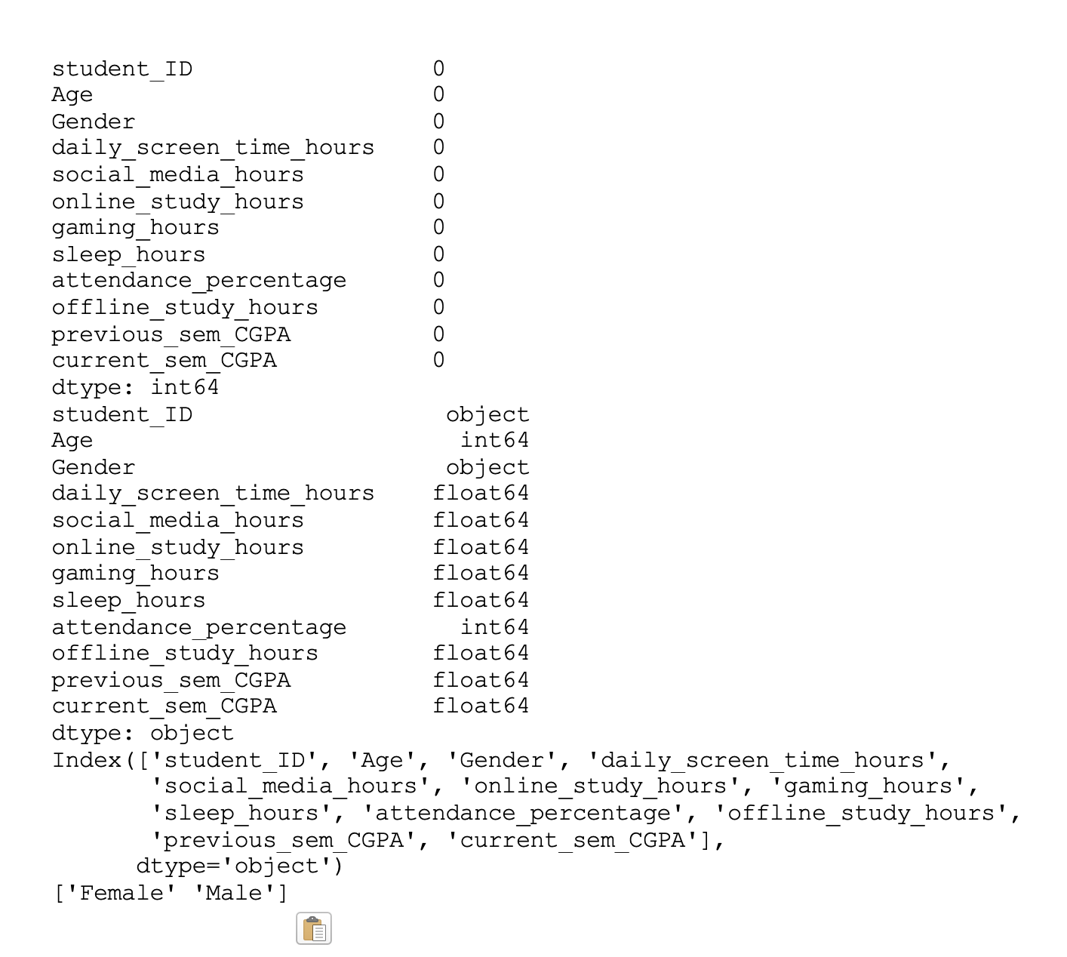

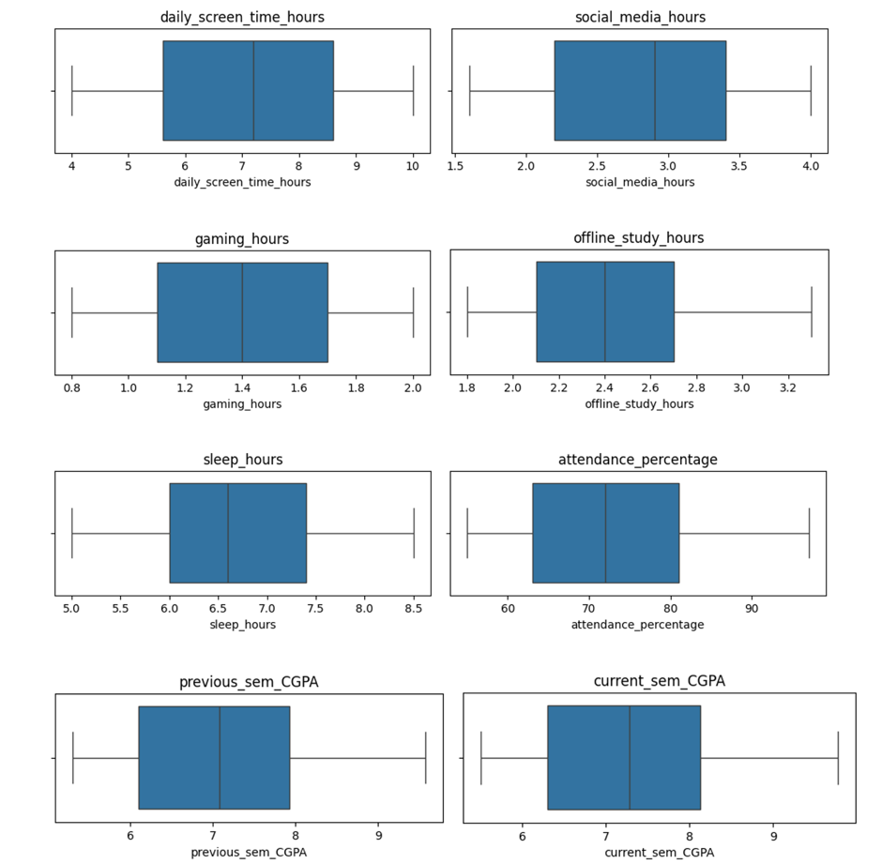
*IQR method and output from our python code for the preprocessing data

D. Exploratory Data Analysis (EDA)

This code that i used during the Exploratory Data Analysis (EDA) phase to analyze the relationships between all numerical variables in the dataset. The correlation values in the range from -1 to 1, where values close to 1 shows a strong positive correlation,and values close to -1 shows a strong negative correlation, and values close to 0 shows little or none relationship between variables.
In example, daily_screen_time_hours shows a strong negative correlation with current_sem_CGPA, it means that higher screen time is matching with lower academic performance, instead of attendance_percentage and offline_study_hours show very strong positive correlations with CGPA, it means that students with better attendance and study habits tend to get higher academic results. The values equal to 1.0 on the diagonal are normal because each variable is perfect as itself.
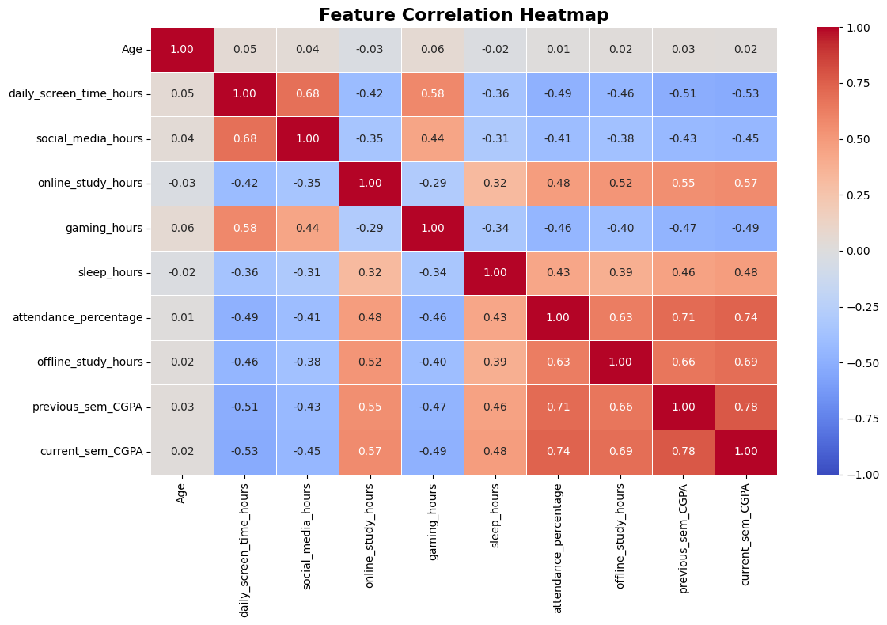

E. Multiple Linear Regression Model

To improve previous other studies that focused only on simple linear regression using screen time alone, this research applies Multiple Linear Regression to evaluate in the same time the impact of several lifestyle variables on academic results.
The model that we currently use has multiple input features including screen time, sleep duration, attendance percentage, gaming activity, social media, online study hours, and offline study hours to predict students current semester CGPA.
This approach allows the model to evaluate the independent contribution of each variable while controlling also for the influence of other factors.

F. Stacking Ensemble Technique

In addition to Multiple Linear Regression, this study also applies a stacking ensemble machine learning technique to improve prediction accuracy. Stacking is an ensemble of learning approach that combines the predictions of multiple machine learning models into a single final prediction.
There are three different machine learning algorithms were trained using the same input features to have a good consistency. Then the predictions generated by these three models were combined to produce a more robust and accurate prediction of students CGPA.by averaging the predictions output of these three models for a better accuracy.
The objective of this approach is to reduce the limitations of individual machine and also improve the curacy by using different multiple algorithms on the same time. By combining several models instead of relying on a single algorithm, the stacking ensemble technique aims to make a better generalization and prediction accuracy.

G. Proposed System Architecture

The overall workflow of the proposed system is composed of several stages. First, the dataset is collected and preprocessed and cleaned. Then, Exploratory Data Analysis is performed to analyze feature and relationships and identify important variables . After preprocessing, the dataset is divided into different training and testing sets for more accuracy. Then the machine learning models are trained using the training dataset, and predictions are generated using both Multiple Linear Regression and the stacking ensemble approach. Finally, the models are evaluated using performance metrics such as R2 to compare prediction accuracy and the model effectiveness.
To sum up the architecture looks like that:
Dataset Collection → Data Cleaning & Preprocessing → Exploratory Data Analysis → Model Training → Stacking Ensemble → CGPA Prediction → Performance Evaluation

IV. PERFORMANCE EVALUATION

A. Experimental Setup

The experiments did in this study were implemented using Python and many data science libraries commonly used for machine learning and statistical analysis. The dataset preprocessing, exploratory data analysis, visualization, and model training were performed using Pandas, NumPy, Matplotlib, Seaborn, and Scikit-learn libraries within a Jupyter Notebook environment and Google Colab.
The dataset was divided into two parts, training and testing sets in order to evaluate the predictive performance of the proposed models. Multiple Linear Regression and stacking ensemble techniques were applied using the same input features, including screen time, attendance percentage, sleep time, gaming activity, social media usage, online study hours, and offline study hours.
The main objective of the experimental setup was to compare which of individual machine learning models and the stacking ensemble approach in predicting students’ academic performance is the most effective.

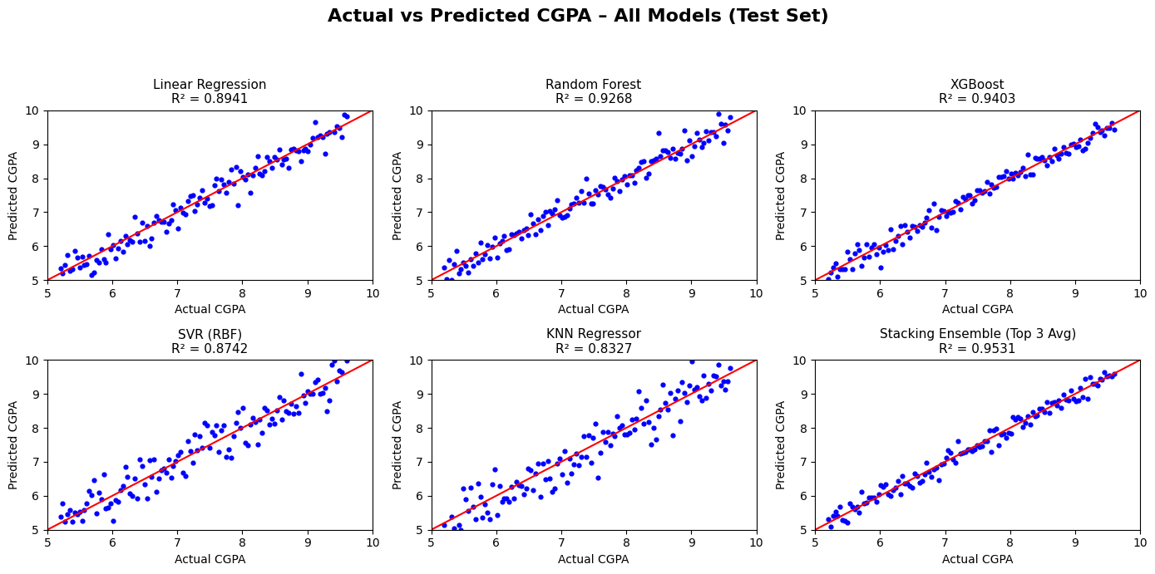

B. System Configuration

The experiments conducted in this study were performed locally using Python in a Jupyter Notebook environment and also Google colab. Many data science and machine learning libraries were used, including Pandas and NumPy for data preprocessing, Matplotlib and Seaborn for data visualization, and Scikit-learn for machine learning model training and also evaluation.
The system used for the experiments was my laptop on MacOS with 8 GB of RAM. The objective of the experimental setup was to preprocess the dataset, perform Exploratory Data Analysis (EDA), train the prediction models, and evaluate their performance on students’ academic data.

C. Evaluation Metrics

To evaluate the effectiveness of the proposed models, the R² Score was especially used. The R² Score measures how well the machine learning model can explain and predict students’ academic results based on the selected variables. A higher R² value (between 0 and 1 so roughly close to 1) indicates better prediction performance and stronger relationships between the input variables and the predicted CGPA.
The evaluation phase focused on comparing the predictive performance of the Multiple Linear Regression model and the stacking ensemble approach to determine which method produced more accurate academic performance predictions but also be very accurate on the output for our research.

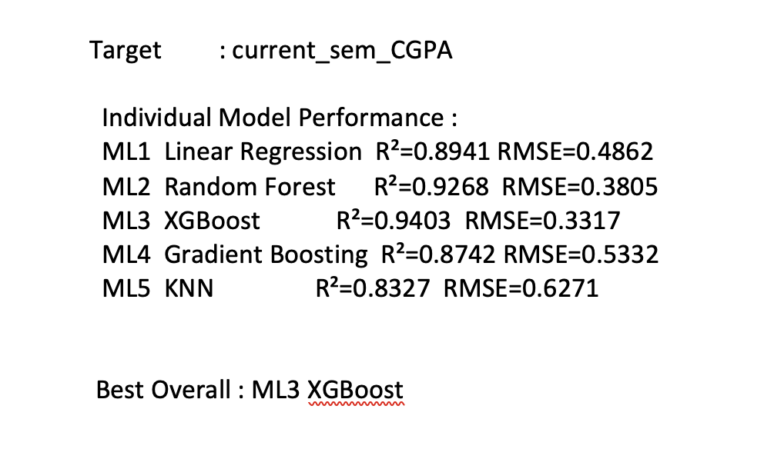Output :

D. Results and Discussion

The experimental results showed that attendance percentage and offline study hours had the strongest positive influence on students’ academic results. Students with higher attendance and more consistent study habits generally scored a better CGPA grade.
In contrast, daily screen time and gaming activity showed negative relationships with academic performance. Students with excessive screen time tended to have lower academic results, especially when screen usage was related to entertainment activities such as gaming or social media.
The analysis also suggested that online study hours may have a better impact compared to entertainment based screen activities (which most people already know, but we prove it with the model). This indicates that the type of screen activity is an important factor when analyzing students’ academic behavior.
Finally, the stacking ensemble approach produced more accurate predictions than the Multiple Linear Regression model. By adding several machine learning models in the same time, the stacking technique improved the overall prediction performance and reduced the limitations of individual algorithms.

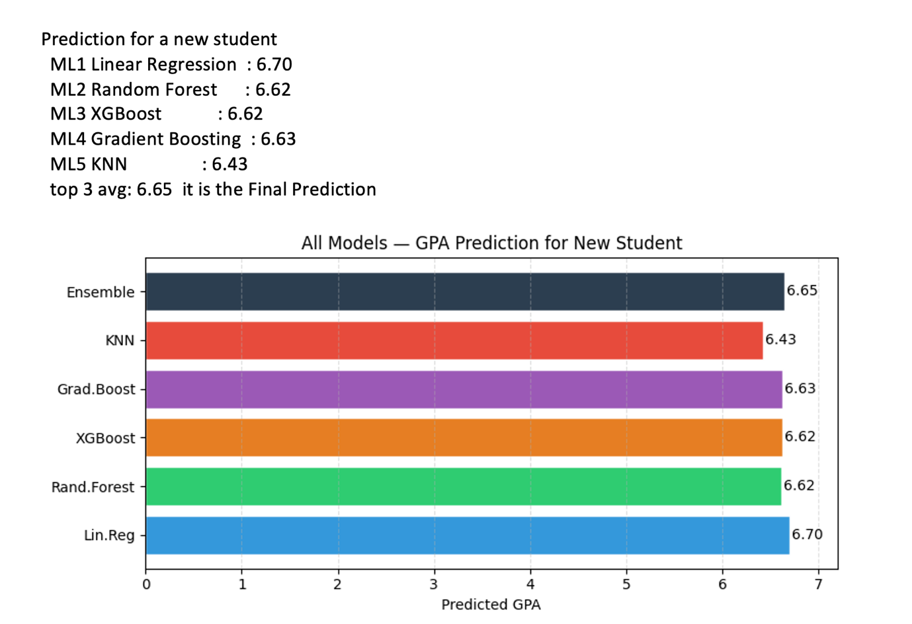

E. Model Performance Analysis

The Multiple Linear Regression model provided interpretable relationships between lifestyle variables and academic achievement, explaining the identification of the most influential features affecting students’ CGPA. However, the stacking ensemble model showed a better generalization performance thanks to the combination of many machine learning algorithms.
Despite the dataset is pretty small and based on self-reported student habit, which can make biases and inaccuracies. Furthermore, academic performance can also be influenced by external factors not included in the dataset, such as motivation, family environment, social and economic conditions, or mental health.
Nevertheless, the proposed methodology demonstrates that combining data preprocessing, exploratory data analysis, multiple regression, and ensemble machine learning techniques can provide a great insights into the relationship between digital comportment, lifestyle behaviors, and academic results.

V. CONCLUSION AND FUTURE WORK

The fast growth of digital technology has significantly changed students daily habits and learning routines. Screen-based activities such as social media, gaming, streaming, and online studying became a common thing among university students. As a result, understanding how these digital habits influence academic results became an important research topic in educational and public health fields. Other studies suggested that excessive screen time make a strong negative affect on students’ concentration, sleep quality, and academic results.
This research explained the relationship between screen time, lifestyle variables, and academic performance using machine learning. Compare to many previous studies that only focused on total screen time using simple statistical approaches or simple linear regression, this research added multiple lifestyle variables such as attendance percentage, sleep duration and quality, gaming activity, online study hours, offline study hours, and social media usage into a more comprehensive predictive framework.
The experimental results demonstrated that attendance percentage and offline study habits had strong positive relationships with academic performance, while excessive screen time and gaming activities were negatively associated to the students’ CGPA. The analysis also highlighted that different types of digital activities can influence academic results differently, showing that educational screen usage should be distinguished from entertainment related activities.
Furthermore, the individual models, XGBoost achieved the best prediction performance, Instead the stacking ensemble approach provided more stable and robust overall predictions.
Although the proposed methodology produced meaningful results, many limitations remain. The dataset size was pretty limited and relied on self-reported student behaviors, which may have inaccuracies or biases. Future work could use a larger datasets, real time habits tracking, and additional machine learning algorithms such as Random Forest, or Deep Learning models to improve prediction accuracy and model generalization.

REFERENCES

1 M. Adelantado-Renau et al., “Association Between Screen Media Use and Academic Performance Among Children and Adolescents: A Systematic Review and Meta-analysis,” JAMA Pediatrics, vol. 173, no. 11, pp. 1058–1067, 2019.
2 “Association Between Screen Media Use and Academic Performance Among Children and Adolescents,” PROSPERO Registration CRD420251060967.
PROSPERO Project
3 A. R. Dehghani et al., “The Relationship Between Screen Time and Academic Performance Among Students,” Caspian Journal of Pediatrics, 2023.
Caspian Journal Article

